**INDIAN AGRICULTURAL CROP PRODUCTION ANALYTICAL REPORT (1991-2021)**

INTRODUCTION:

Agriculture is an important sector in India. It is in dispensable for the sustenance and growth of the Indian economy. On an average, about 70% of the households and 10% of the urban population is dependent on agriculture as their source of livelihood. Today, India is a major supplier of several agricultural commodities like tea, coffee, rice, spices, oil meals, fresh fruits, fresh vegetables, meat and its preparations and marine products to the international market. India is a large producer of several agricultural products.

**USES:**

1. Agriculture provides most of the world's food and fabrics.
2. Cotton, wool, and leather are all agricultural products.
3. Agriculture also provides wood for construction and paper products.
4. These products, as well as the agricultural methods used, may vary from one part of the world to another.

**EMPATHY MAP:**

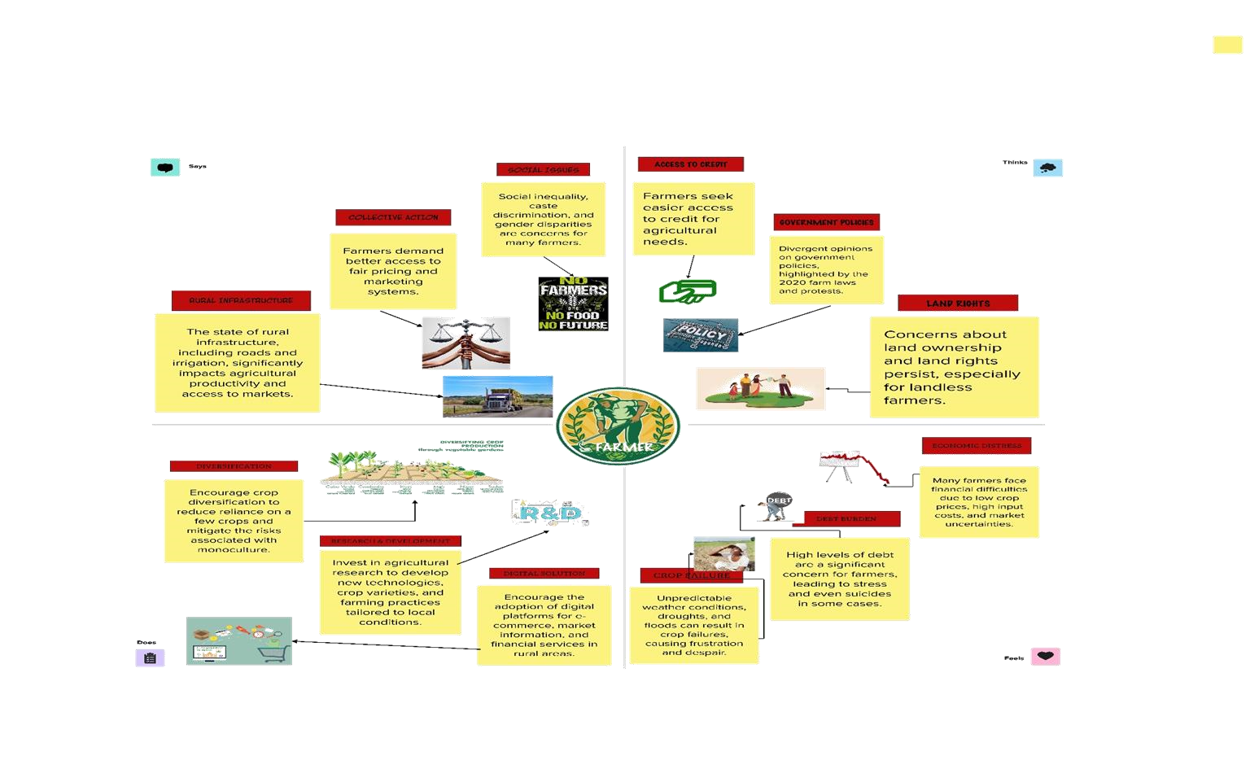

**BRAINSTROM:**

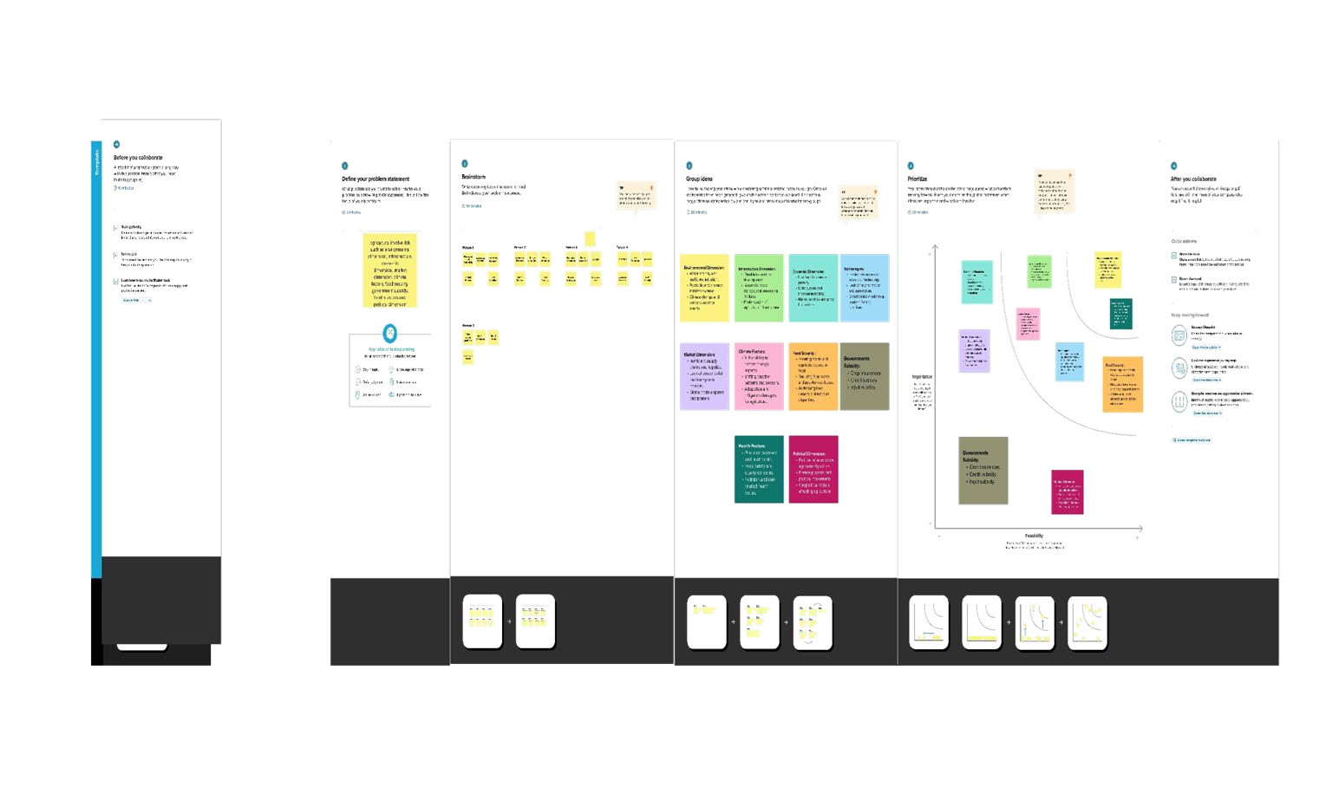

**RESULT:**

We are able to well analyse the farmer data clearly about different sector.

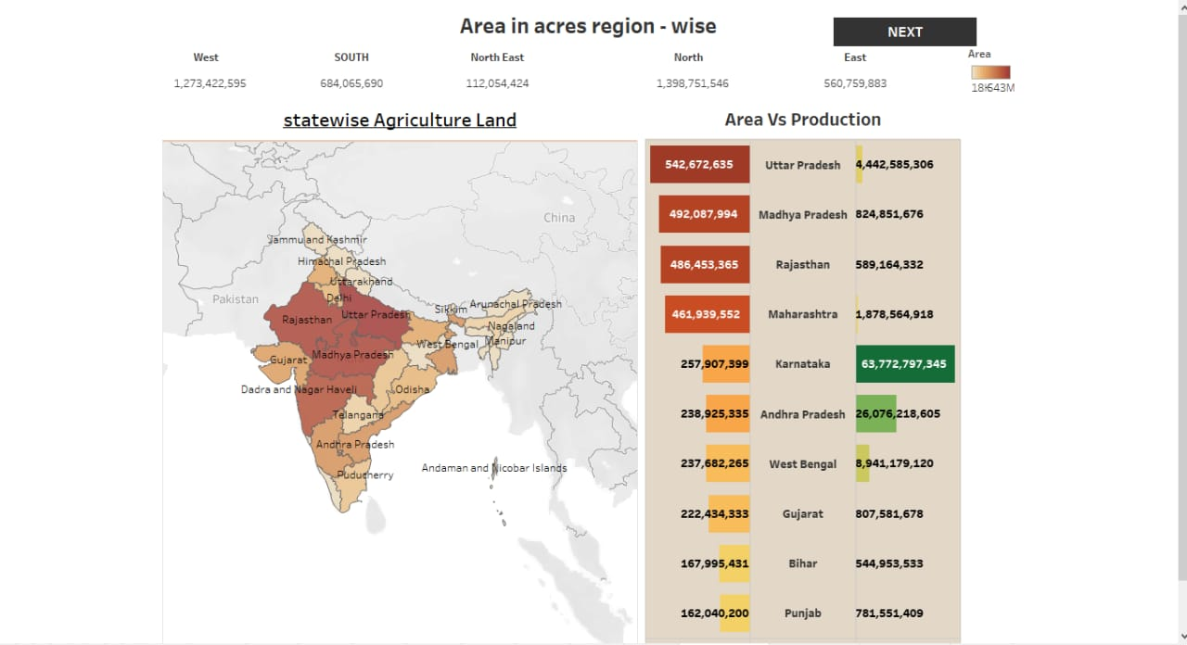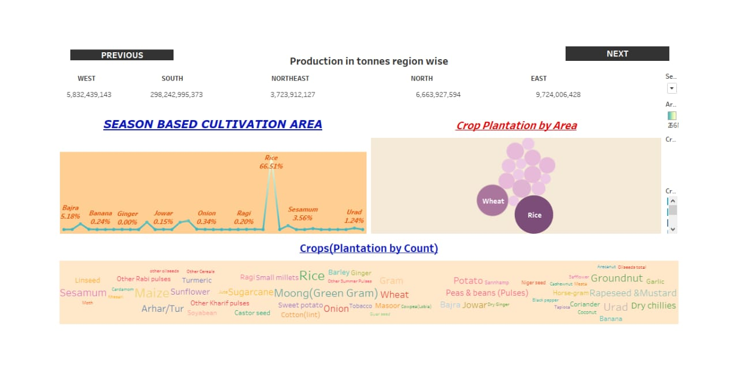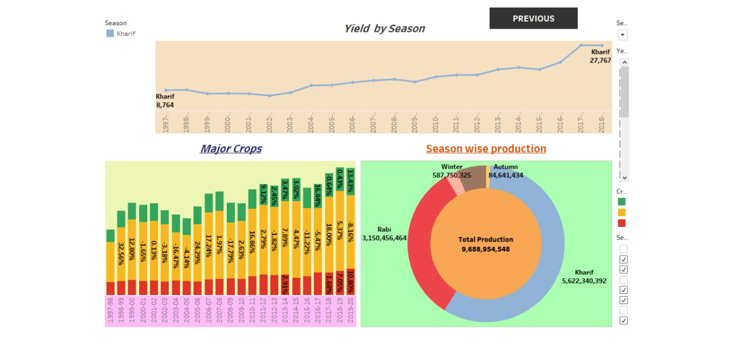**ADVANTAGE:**

1. We can find and sort out the farmer’s problems.
2. Clear data about employee’s job satisfaction.

**DISADVANTAGE:**

1. Unclear directions on cash crops.
2. Lack of labour forces

**APPLICATIONS:**

1. Measuring performance.
2. Examining soil fertility.

**CONCLUSION:**

By collecting and analysing data related to the farming can help make measure impact of initiatives and shape of future.

**FUTURESCOPE:**

1. Strategic implement technology.
2. Great initiatives on marketing food crop as cash crops.
3. Development opportunities. 4. Reduces disguised unemployment.